Digital Logic Design Laboratory

Lab 4

Multiplexers

Full name: Nguyễn Minh Đức

Student number: EEACIU22168

Class: Monday

Date: 20/5/2024

# I. Objectives

In this laboratory, students will study:

- Understand and design a multiplexer.

- Use a multiplexer and design/implement a circuit based on a function definition.

- Design combinational circuits using MUX.

# II. Procedure

1. Design multiplexer using logic gates

a. Design 2-to-1 multiplexer using logic gates:

A 2-to-1 multiplexer has I0 and I1 are the two inputs, S is the selector input, and Y is the output. When S = 0 then Y = I0 but when S = 1 then Y = I1. The Figure 1 shows the illustration of MUX 2-1.

MUX 2- 1

I0

I1

S

Y

Figure 1. The illustration of MUX 2-1.

Built the truth table:

|  |  |  |  |
| --- | --- | --- | --- |
| Input | | | Output |
| S­ | I0 | I1 | Y |
| 0 | 0 | 0 | 0 |
| 0 | 0 | 1 | 0 |
| 0 | 1 | 0 | 1 |
| 0 | 1 | 1 | 1 |
| 1 | 0 | 0 | 0 |
| 1 | 0 | 1 | 1 |
| 1 | 1 | 0 | 0 |
| 1 | 1 | 1 | 1 |

The expressions:



|  |  |  |
| --- | --- | --- |
|  | 0 | 1 |
| 00 | 0 | 0 |
| 01 | 1 | 1 |
| 11 | 0 | 1 |
| 10 | 0 | 1 |

$$\overline{S}I_{0}+I_{0}I_{1}+SI_{1}$$

Implement the circuit via simulation software and paste the result in here

Make comment on the results

A 2-to-1 multiplexer has I0 and I1 are the two inputs, S is the selector input, and Y is the output. When S = 0 then Y = I0 but when S = 1 then Y = I1. This mux can be built as the following expression $\overline{S}I_{0}+I_{0}I_{1}+SI_{1}$

b. Design 4-to-1 MUX using logic gates.

Build the circuit. The inputs S0, S1, I0, I1, I2, I3 are driven by 6 switches.

|  |  |  |
| --- | --- | --- |
| Input | | Output |
| S0­ | S1 | Y |
| 0 | 0 | I0 |
| 0 | 1 | I1 |
| 1 | 0 | I2 |
| 1 | 1 | I3 |

The expressions:

S0’S1’I0 + S0’S1I1 + S0S1’I2 + S0S1I3

Implement the circuit via simulation software and paste the result in here

Make comment on the results

The result of the 2-to-1 multiplexer is determined by the combination of S1 and S0. For instance, when S1S0 = 01 and I1 is LOW, the output Y will be LOW as well, demonstrating the direct influence of the selector inputs on the final output.

c. Design 4-to-1 MUX using 3 MUX 2-1.

Implement the circuit via simulation software and paste the result in here

Make comment on the results

The 4-to-1 multiplexer, made from three 2-to-1 multiplexers, uses three selector inputs 𝑆2,𝑆1,𝑆0. When 𝑆 is high, the output 𝑌 depends on 𝐷1 of the final multiplexer, specifically the second data input. When 𝑆 is low, the output 𝑌 depends on 𝐷0 of the final multiplexer, specifically the first data input.

2. Investigate IC 8-to-1 Multiplexer (74HC151)

Construct the circuit as below:

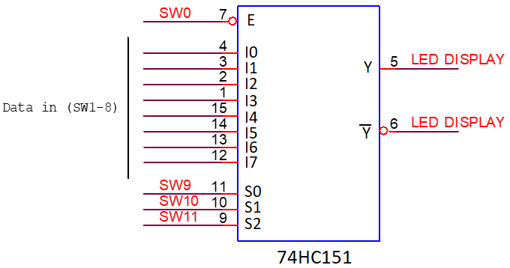

Figure 2. IC 8-to-1 Multiplexer (74HC151)

- 2 outputs are connected by using LEDs.

- The inputs are controlled by switches.

- Observe the results and fulfill the truth table

|  |  |  |  |  |  |
| --- | --- | --- | --- | --- | --- |
| INPUT | | | | OUTPUT | |
| S2 | S1 | S0 | E | Y | $$\overline{\text{Y}}$$ |
| X | X | X | 1 | 1 | 0 |
| 0 | 0 | 0 | 0 | $$I_{0}$$ | $${\overline{I}}_{0}$$ |
| 0 | 0 | 1 | 0 | $$I_{1}$$ | $${\overline{I}}_{1}$$ |
| 0 | 1 | 0 | 0 | $$I_{2}$$ | $${\overline{I}}_{2}$$ |
| 0 | 1 | 1 | 0 | $$I_{3}$$ | $${\overline{I}}_{3}$$ |
| 1 | 0 | 0 | 0 | $$I_{4}$$ | $${\overline{I}}_{4}$$ |
| 1 | 0 | 1 | 0 | $$I_{5}$$ | $${\overline{I}}_{5}$$ |
| 1 | 1 | 0 | 0 | $$I_{6}$$ | $${\overline{I}}_{6}$$ |
| 1 | 1 | 1 | 0 | $$I_{7}$$ | $${\overline{I}}_{7}$$ |

Implement the circuit via simulation software and paste the result in here

Briefly describe the operation of the IC

The final result Y = I(S2S1S0), for example if S2S1S0 = 010 then Y = I(2) = I2, if I2 is High then Y will be high and vice versa

3. Implement the 3-variable logic function using 74HC151

- Implement Boolean expression using IC 74HC151.

- The data inputs S0, S1, S2 are connected to switches.

- Implement the circuit and verify the truth table

a. $f\left(S_{2},S_{1},S_{0}\right)= \sum_{S_{2}S_{1}S_{0}}^{ }{\left(1,3,5,6\right)}=I_{3}+I_{6}+I_{1}+I_{5}$

Implement the circuit via simulation software and paste the result in here

Make comment on the results

$f\left(S_{2},S_{1},S_{0}\right)=I_{3}+I_{6}+I_{1}+I_{5}$ so the result Y is High when S2S1S0 = (1,3,5,6) or 001,011,101,110

b. $f\left(S_{2},S_{1},S_{0}\right)= \sum_{S_{2}S_{1}S_{0}}^{ }{\left(2,3,4,7\right)}=I_{2},I_{3},I_{4},I_{7}$

Implement the circuit via simulation software and paste the result in here

Make comment on the results

$f\left(S_{2},S_{1},S_{0}\right)=I_{2},I_{3},I_{4},I_{7}$ so the result Y is High when S2S1S0 = (2,3,4,7) or 001,011,100,111

4. Implement the 4-variable logic function using 74

a. Implement the connected diagram using 74HC151.

Construct the circuit as Figure 3:

Change the logic levels of the inputs C, B, A.

Observe and make comment on the results.

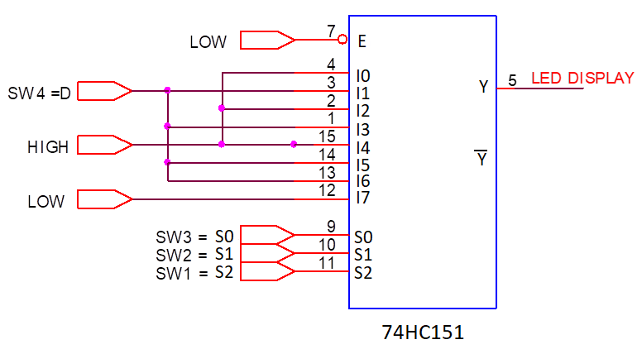

Implement the circuit via simulation software and paste the result in here

Write down the expression of $f(D,S_{2},S_{1},S_{0})$ and make comments on the results

$$f\left(D,S_{2},S_{1},S_{0}\right)=I_{0}+I_{2}+I_{4}+DI_{1}+DI_{3}+DI_{5}+DI_{6}$$

b. Implement logic expression using 74HC151

Given the expression:

$$f\left(D,S_{2},S_{1},S_{0}\right)=D S_{2} \overline{S_{1}} S_{0}+S_{2} S_{1} \overline{S_{0}}+\overline{S_{2}} S_{1} S_{0}+\overline{D}\overline{S_{2}} \overline{S_{1}}S_{0}$$

$$=D101+110+011+\overline{D}001$$

$$=DI_{5}+I_{6}+I_{3}+\overline{D}I_{1}$$

Draw the block diagram

Implement the circuit via simulation software and paste the result in here

Make comments on the results

$f\left(D,S_{2},S_{1},S_{0}\right)=DI_{5}+I_{6}+I_{3}+\overline{D}I_{1}$, so the result Y is always high when S2S1S0 = (3,6) = 011,110 . When S2S1S0 = (1,5) = 001,101, Y depends on D ; when D is high, Y at I1 is high, Y at I5 is low, and when D is low Y at I5 is high, Y at I1 is low